The bottom line is results when you buy or sell property and that is precisely what you will get from Brenda Pintabona, Realtor with Realty ONE Group Gold.

Brenda realizes that buying and selling a home is one the most important decisions you will make. She is committed to making that experience as smooth and successful as possible. She understands what is most important to you and your family and will do whatever it takes to make your dreams come true. As your Realtor, she will be there to ensure that your interests are protected and your goals achieved.
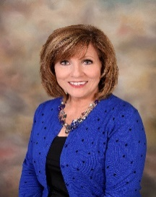

Brenda Pintabona
- Over 14 years experience selling Real Estate
- Specializing in Residential Sellers and Buyers
- Top Agent Producer Award Recipient
- Serving Stanislaus, San Joaquin and Merced Counties
- Active in Community and Church
- Extensive background in Customer Service and Corporate Management.

“People will forget what you said, people will forget what you did, but people will never forget how you made them feel.”
- Maya Angelou

